PHP and MySQL

Session 6 Practical

DB Connectivity & Functions

Exercise 1
The following exercises will only work if you have created the db1_%USERNAME% (where your MySQL username is substituted for %USERNAME%) database from the week 5 practical.
We will now create an html file that contains a form, which will allow users to enter new records into the “test”.
Create the file below and save it as wk6ex1.html.
<html>
<head></head>
<body>
<form action='wk6ex1action.php' method='post'>
Enter name :
<input type='text' name='txtName' /><br/>
Enter email :
<input type='text' name='txtEmail'/><br/>
Enter Tel number :
<input type='text' name='txtPhoneNumber'/><br/><br/>
<input type='submit' value='Save Data' />
</form>
</body>
</html>

Now create the file below and save it as wk6ex1action.php. The script is incomplete and requires several additional lines (see comments), to connect to the server and execute the two SQL statements. Refer to your lecture notes for syntax required for the missing lines.
When complete run wk6ex1.html to see if it does save the new record.
<?php
$sql = "INSERT INTO test (name,email,phone_number) ";
$sql = $sql . " values ('$_POST[txtName]','$_POST[txtEmail]','$_POST[txtPhoneNumber]’)";

// Connect to server and select database

// Execute sql statement

$sql = "SELECT * from test";

// Execute sql statement

while ($row = mysqli_fetch_assoc($result))
{
echo "$row[name] $row[email] $row[phone_number] <br/>";
}
?>

Merge the sql values
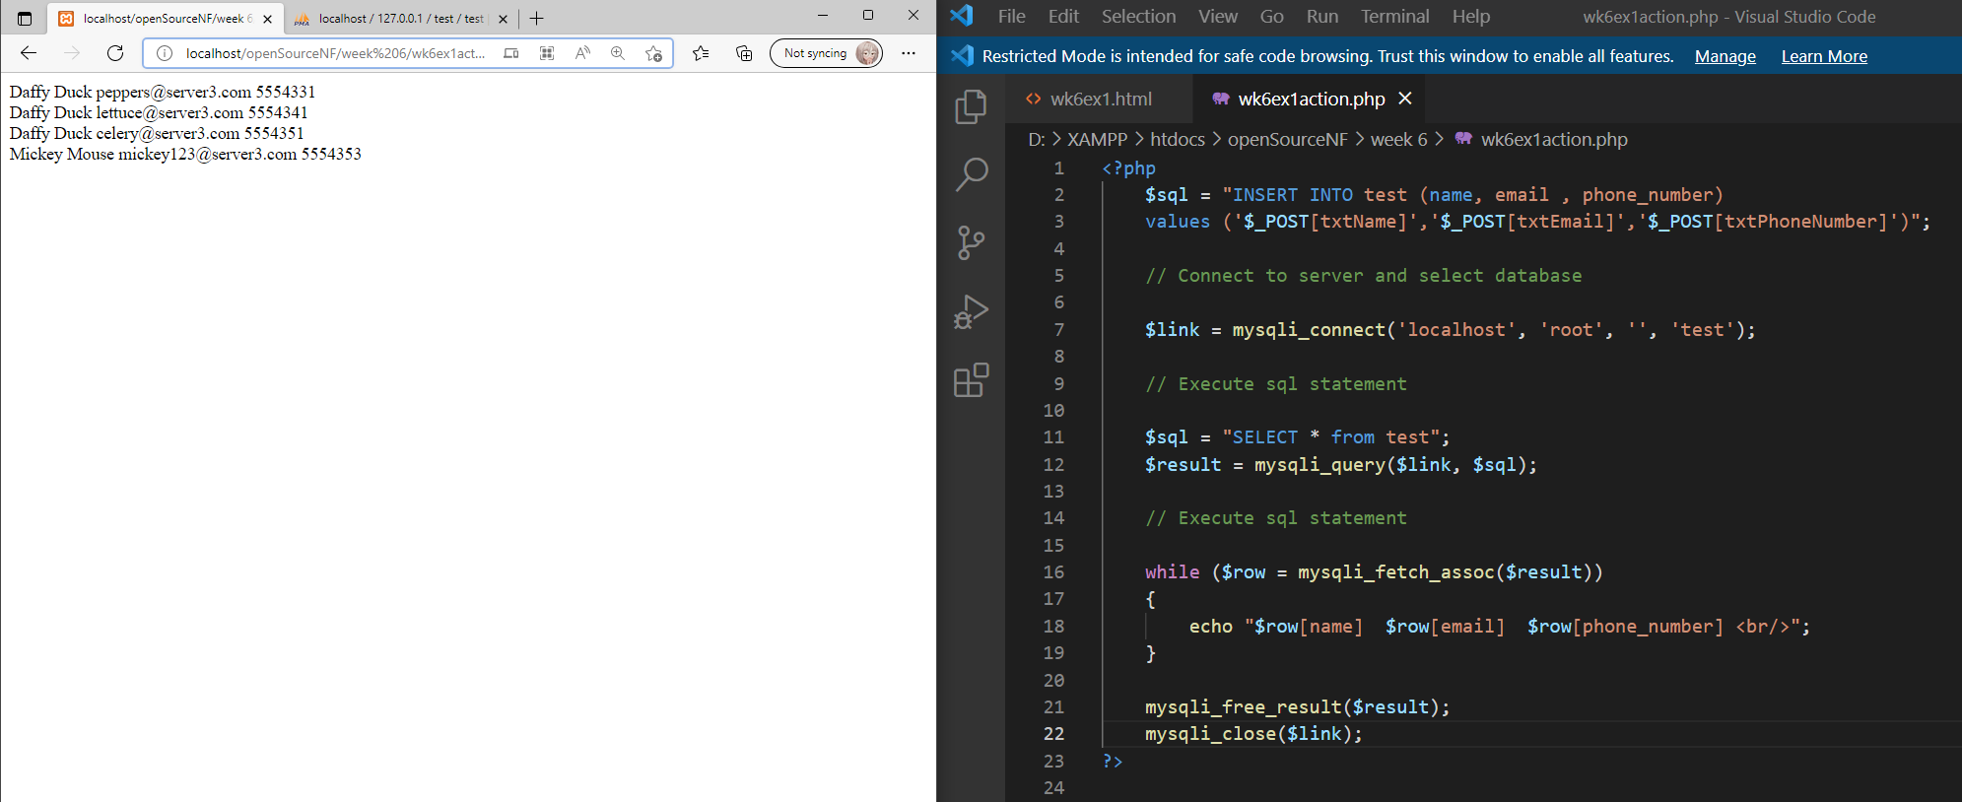

Exercise 2
The next application (containing two new scripts) that will display the people within your test table as a list of links. When you click on one of the links,that persons details will be displayed. Save the file below as wk6ex2.php. Remember to add the code necessary to connect to the server, select the database and execute the query.
<?php

// Connect to server and select database
$sql = "SELECT * from test";
// Execute sql statement

?>
<html>
<body>

<?php
while ($row = mysqli_fetch_assoc($result))
{
echo "<a href=\"wk6ex2action.php?id=$row[name]\">$row[name]</a></br>";
}
?>
</body>
</html>

Now create the file below and save it as wk6ex2action.php. Remember to add the code necessary to connect to the server, select the database and execute the query.
<?php

// Connect to server and select database

$sql = "SELECT * from test where name = '$_GET[id]’ ”;
// Execute query
$row = mysqli_fetch_assoc($result);
?>
<html>
<body>
<form action=” ” method=”post”>

Name :
<input type=text name=txtname value="<? echo $row[name] ?>” readonly />
</br>
Phone number :
<input type=text name=txttelno value="<? echo $row[phone_number] ?>" />
</br>
Email :
<input type=text name=txtemail value="<? echo $row[email] ?>" />
</br>
<input type=submit name=btnsubmit value="save"/>
</form>
</body>

Load wk6ex2.php into your browser and check it works.
Note how the id is sent to wk6ex2action.php as part of the query string and consequently we must use $_GET[id] to pick up its value within the script.

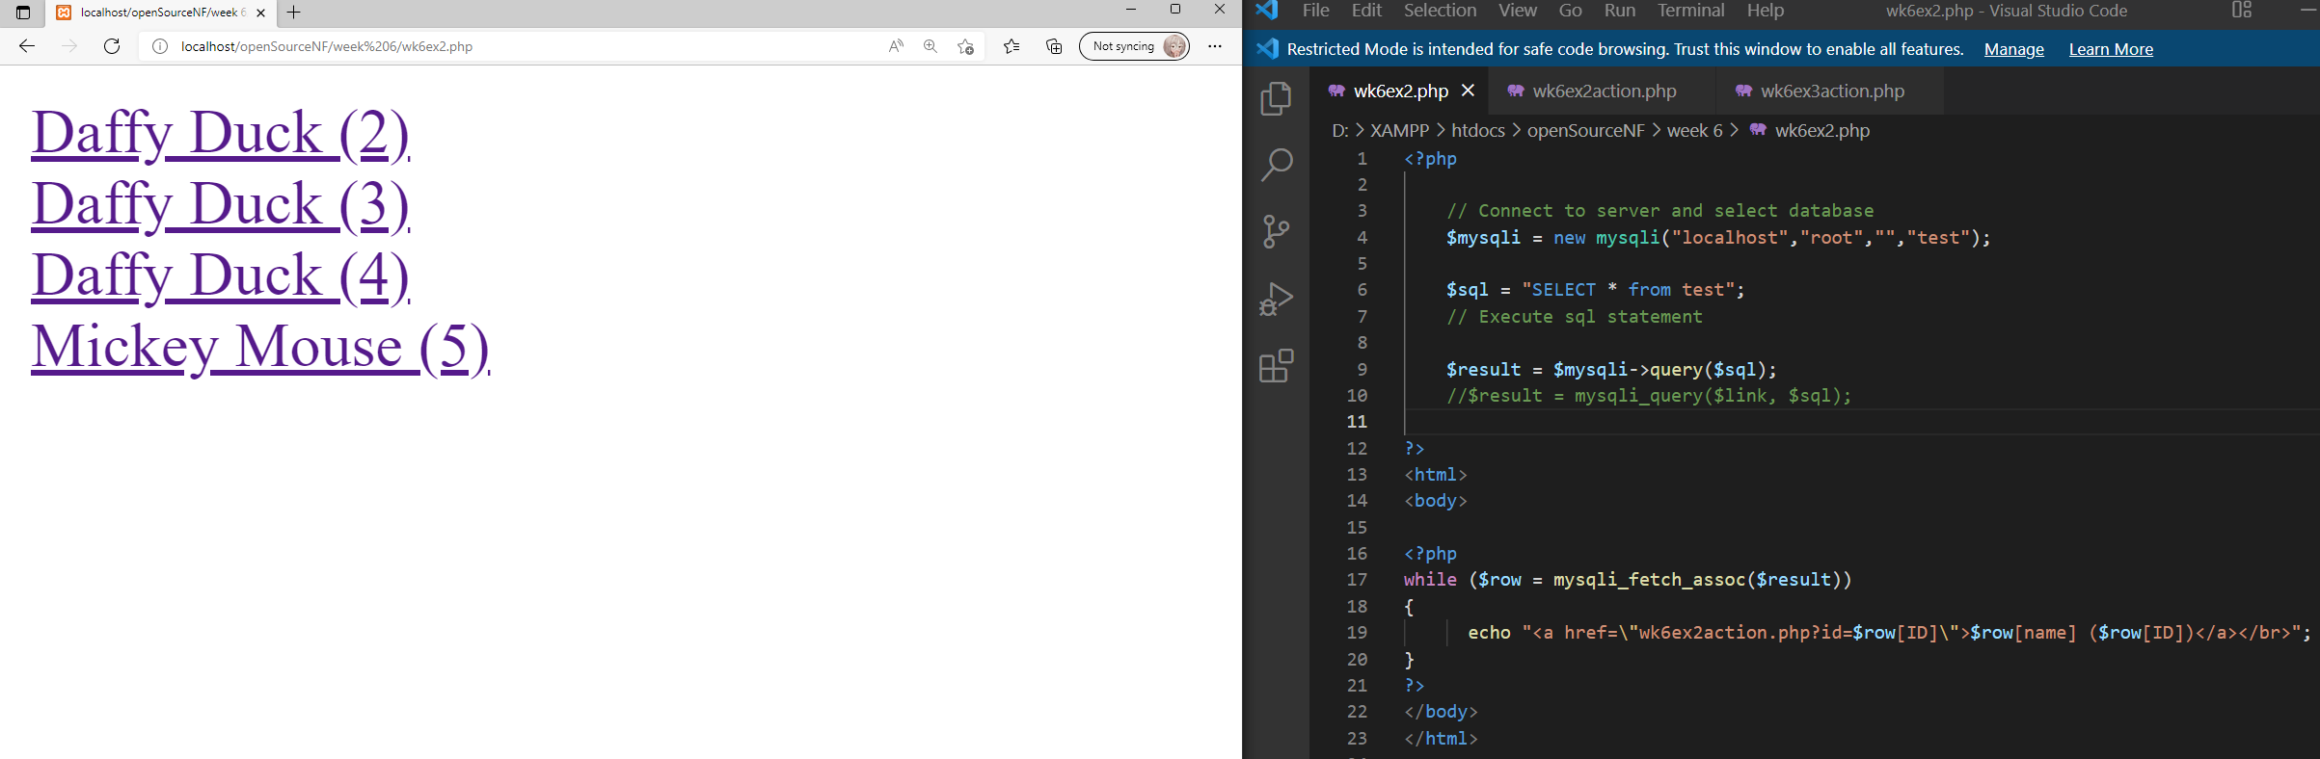

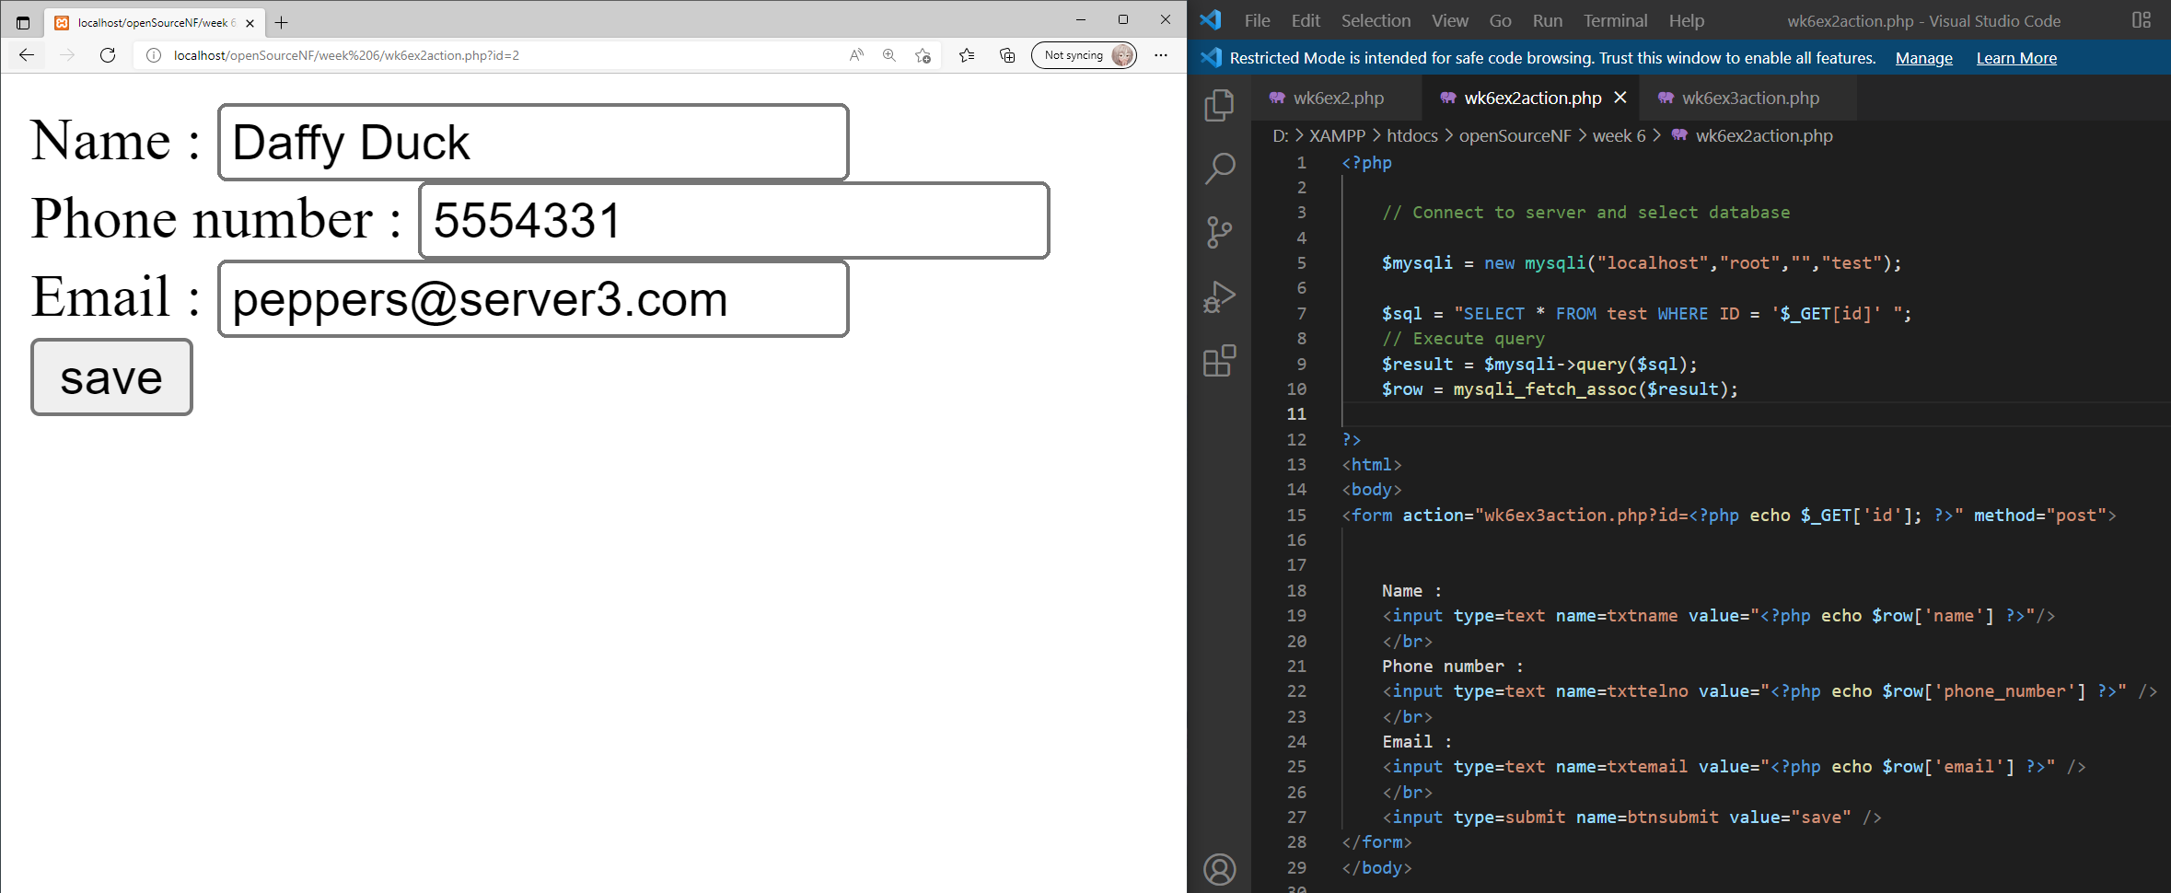

Exercise 3.
While exercise 2 allowed you to select a record and display its contents, it did not allow you to update the data within the record. Create a third script file that will save the changes made to the email and phone number fields within wk6ex2action.php.

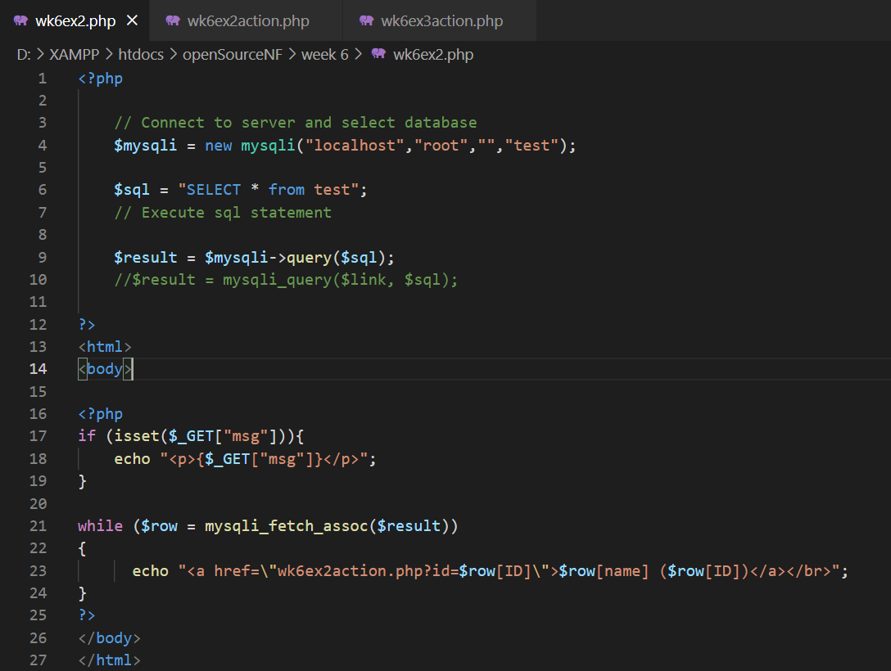
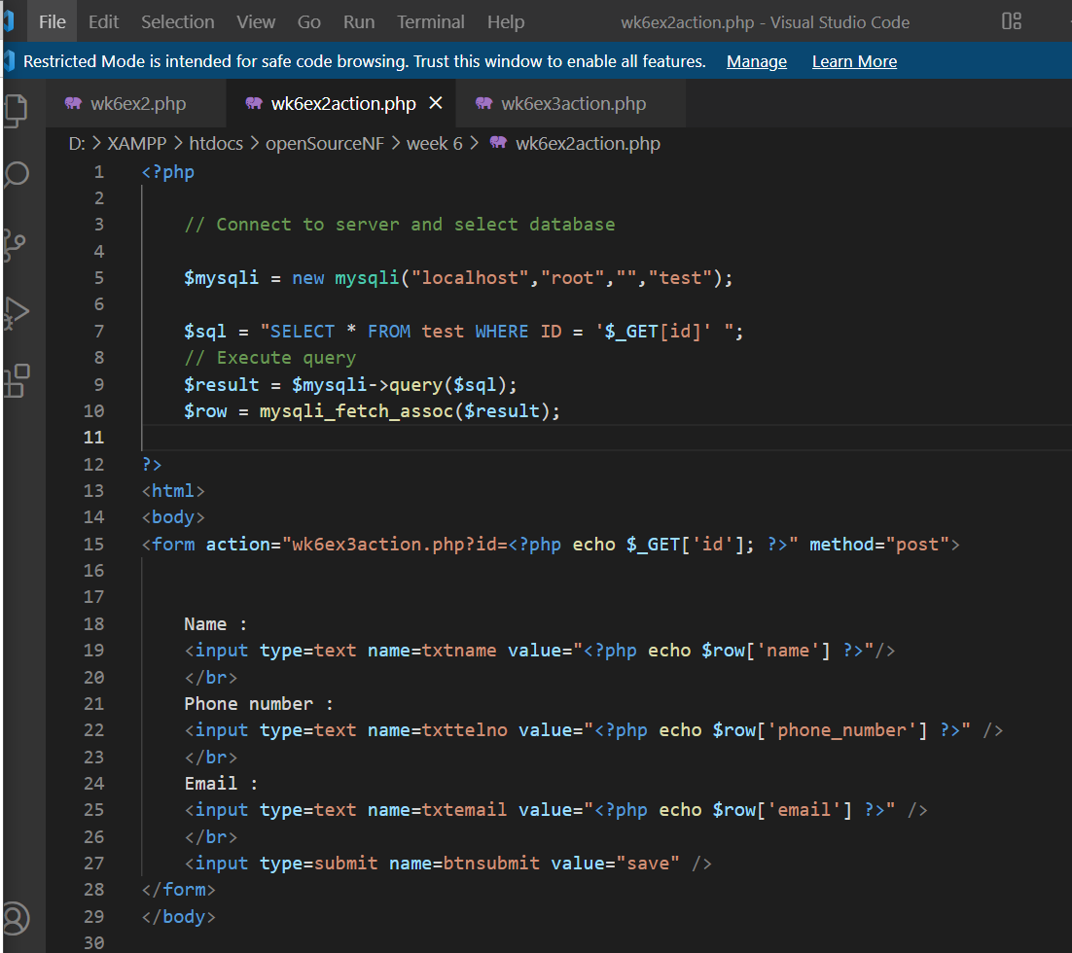
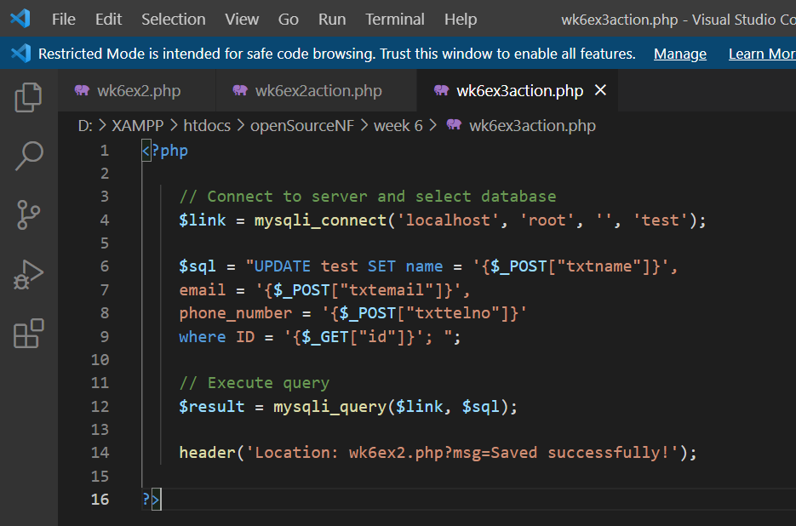

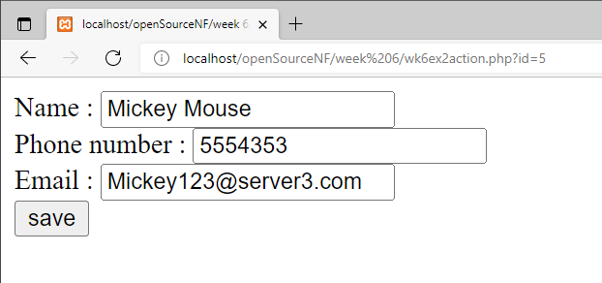
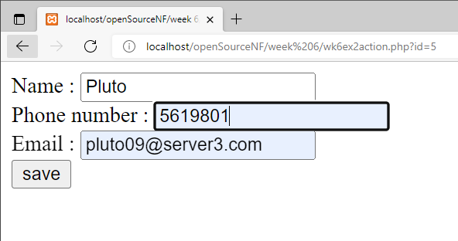

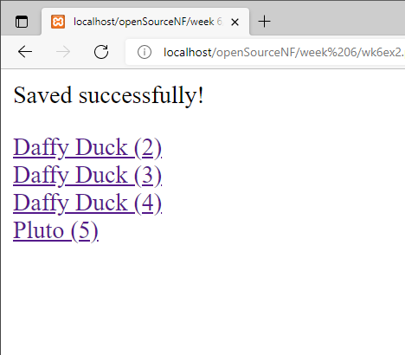

Exercise 4.
Modify the scripts to allow a user to delete a record from the test table.

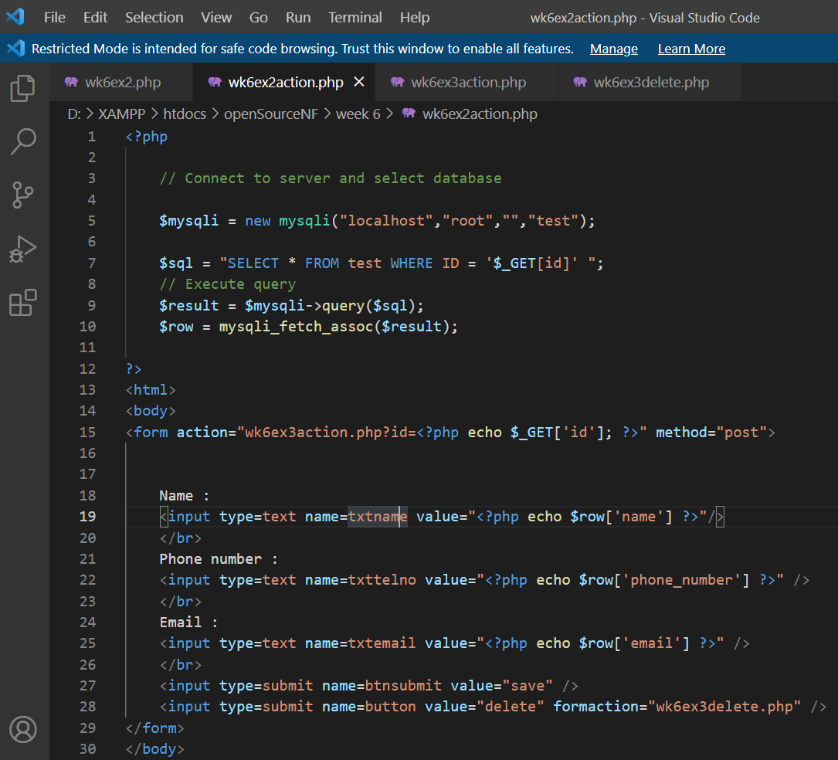

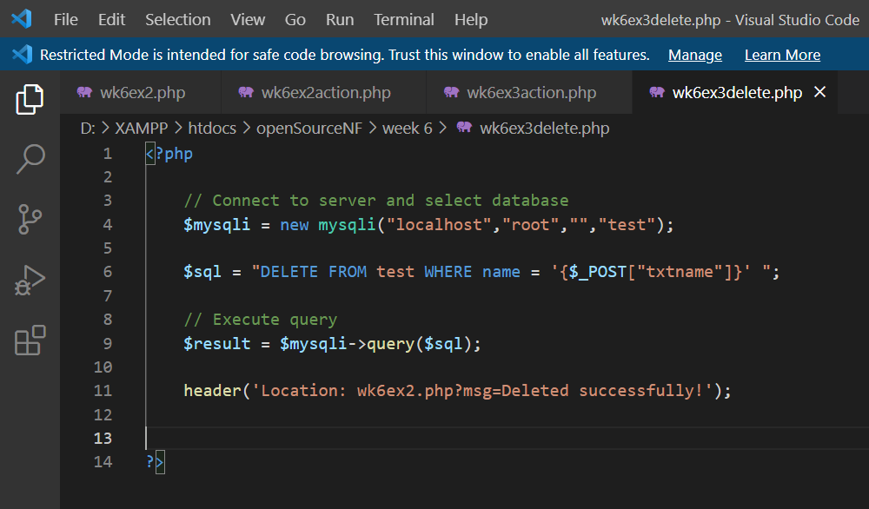

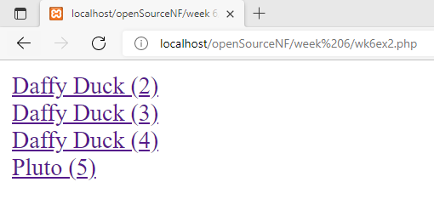

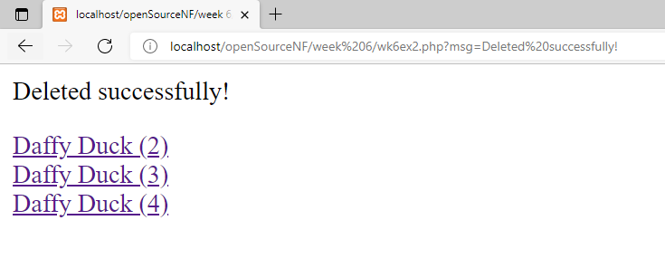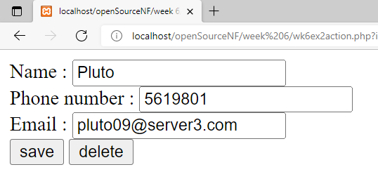
Exercise 5
Like most languages there is a function construct within php, that allows you to name a group of statements, which are executed when the function name is called within your scripts. The two functions below illustrate, how functions might be used to create a basic html document. Create a new file containing the two functions below and name it myfunctions.inc
<?php
function html_header($pageTitle)
{
echo “<html><title> $pageTitle </title></head>”;
echo “<body>”;
}

function html_h1($text)
{
echo “<h1> $text </h1>”;
}

function html_footer()
{
echo “</body>”;
echo “</html>”;
}
?>

Now you must write the script that will call these functions.
Create a new script file containing the script below and save it as wk6ex5.php. Notice how we have passed the name of the file that contains our two functions to the php include function. This will allow us to access these functions even though they are not declared within wk6ex5.php. Now run the script;

<?php
include(“myfunctions.inc”);
html_header(“My first function demo”);
html_h1(“These functions are going to save me lots of time”);
html_footer();
?>

The argument “My first function demo” is passed to the $pageTitle parameter of the html_header function where it is output as the html page title (in the blue bar at the top of your browser). The argument to the html_h1 function is displayed within the <h1> (heading 1) html tags.

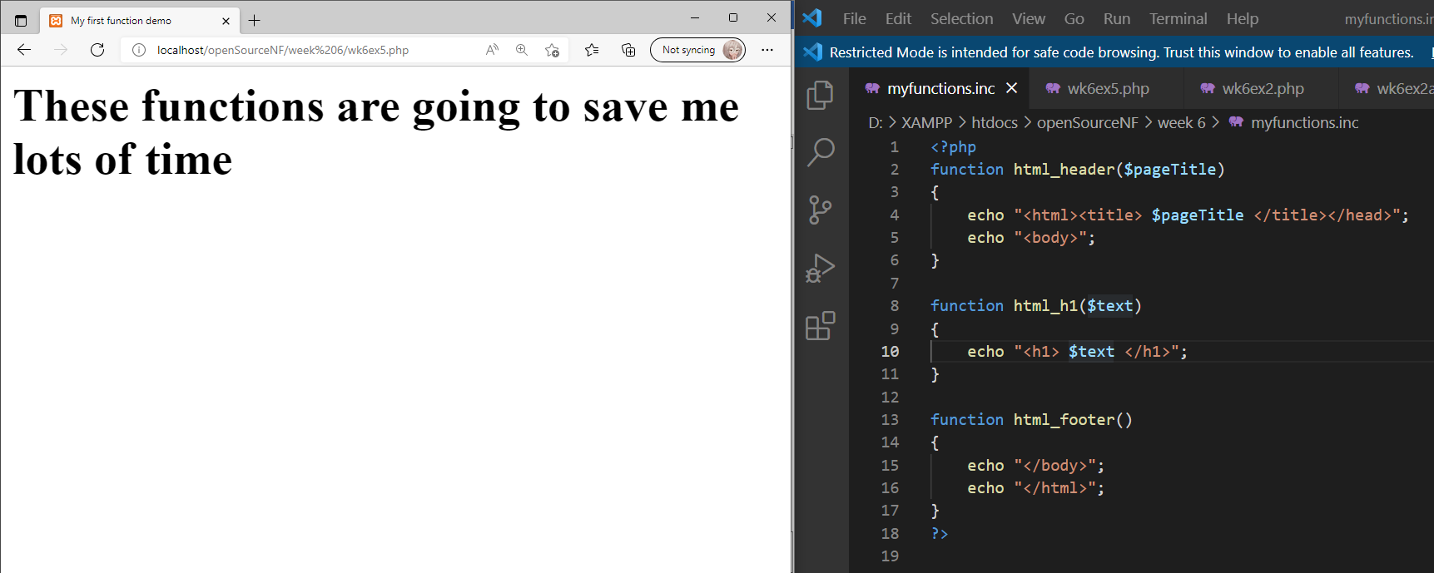

Create your own function within myfunctions.inc that will display the text passed to it in <h2> (heading 2) html tags. Now include a line within wk6ex5.php that will call this function (passing some text as an argument).

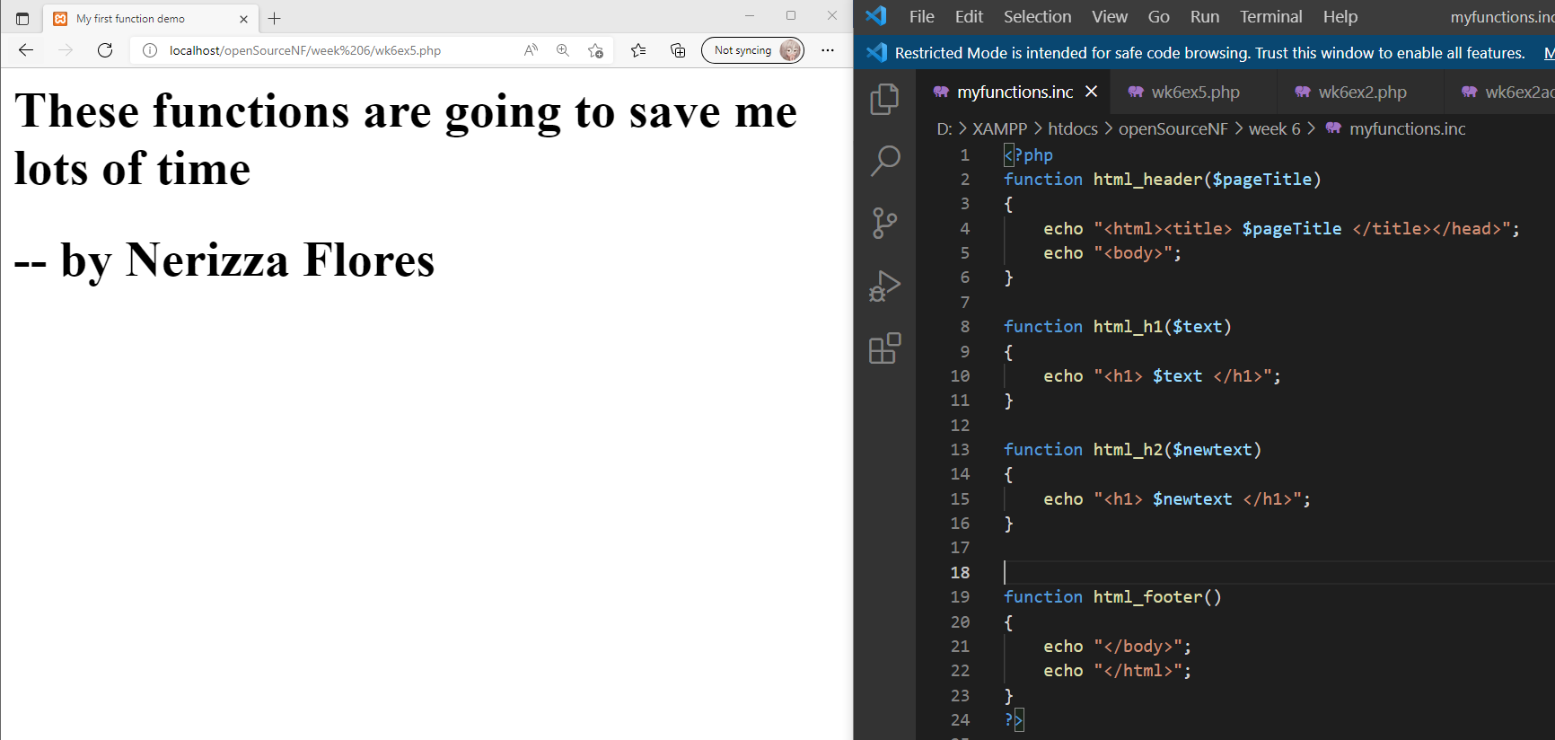

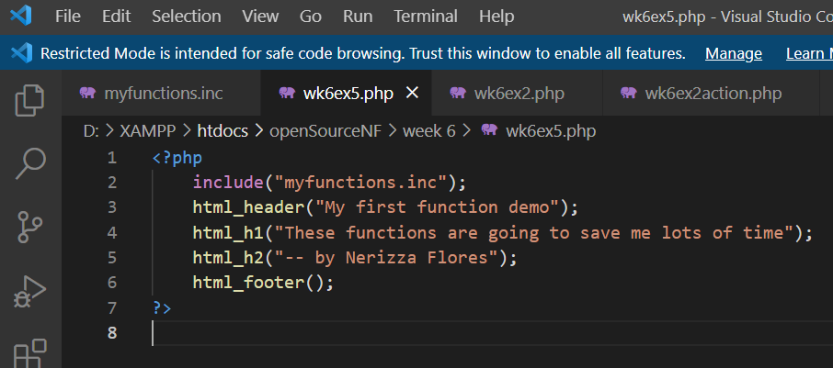

Exercise 6
In addition to generating html code, user defined functions can perform repetitive calculations as in the tax calculating function below. The function takes two arguments, your salary and the % tax rate. Add the calculatetax function to the myfunctions.inc file.
function calculatetax($salary, $rate)
{
$tax = ($salary * ($rate/100));
return $tax;
}

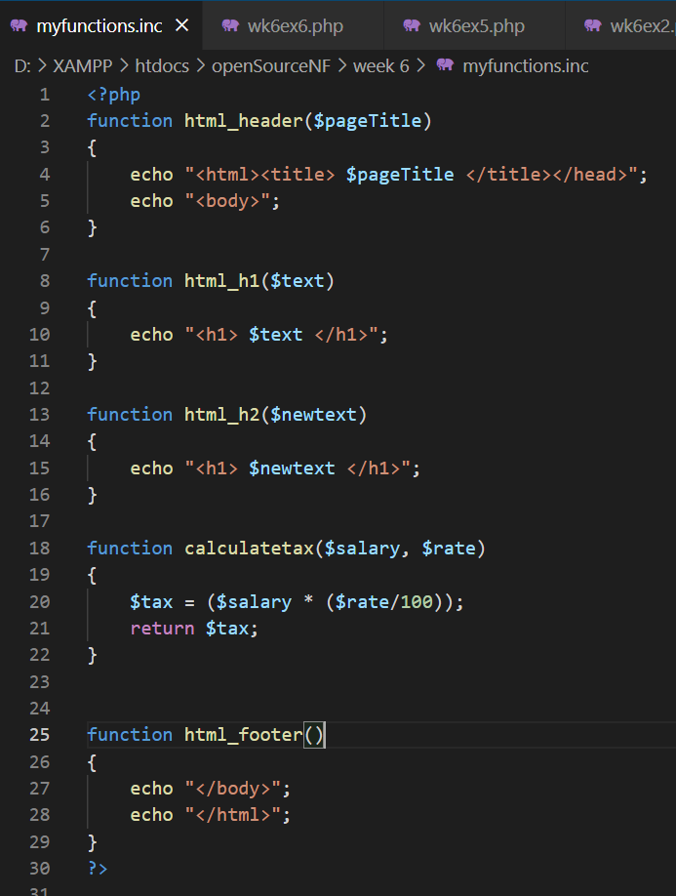

Create a new script file containing the script below and save it as wk6ex6.php. Now run the script. This script assumes your salary is £15,000 and the tax rate is 22%, change these figures to reflect you own income.
<?php
include(“myfunctions.inc”);
html_header(“My second function demo”);
echo “I pay £ “ . calculatetax(15000,22) . “ tax”;
html_footer();
?>

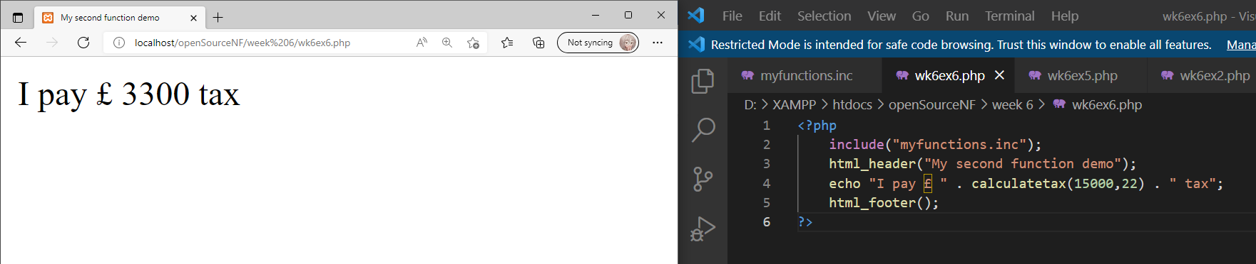

Exercise 7
We can assign a default value to a parameter by setting its value in the functions declaration (as below). These default values will be assigned to a parameter, if you don’t pass a value when you call the function. Amend the calculatetax function contained within myfunctions.inc to provide a 40 percent default value to the tax rate.
function calculatetax($salary, $rate=40)
{
$tax = ($salary * ($rate/100));
return $tax;
}

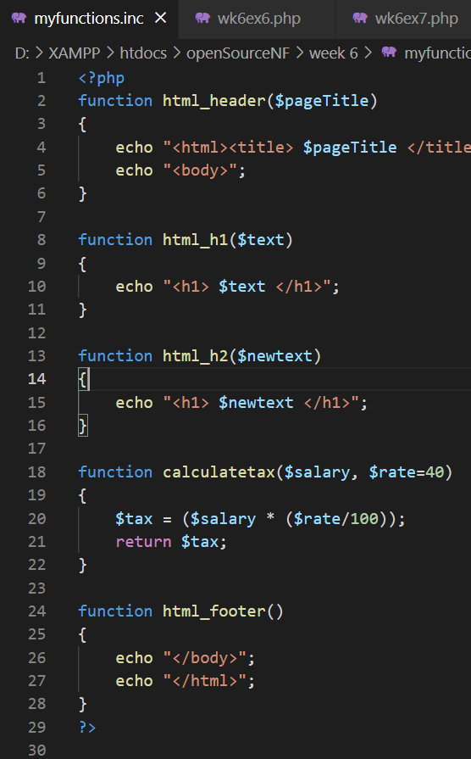

Now remove the tax rate argument from the call to the calculatetax function defined in wk6ex6.php and run the script.
<?php
include(“myfunctions.inc”);
html_header(“My second function demo”);
echo “I pay “ . calculatetax(15000) . “ tax”;
html_footer();
?>

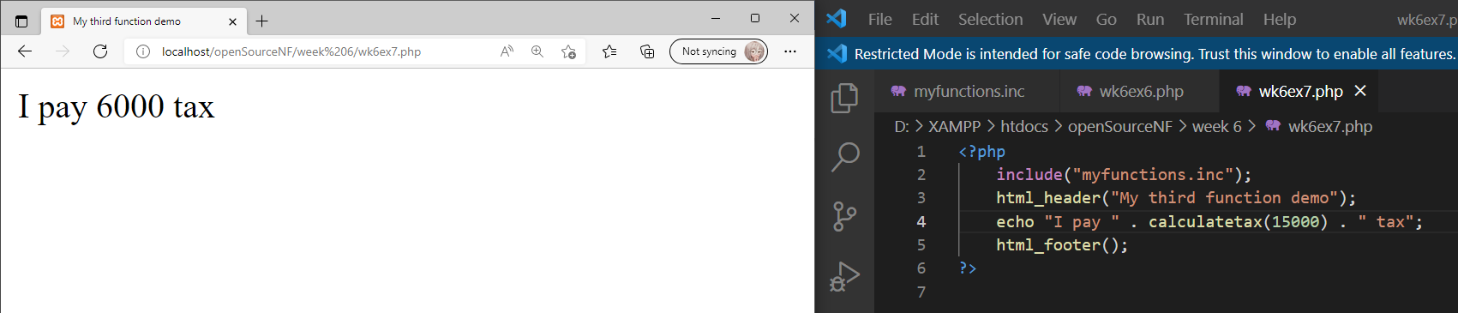

Exercise 8
The calculatetax function does not take into account the tax allowance (that is the first x pounds you earn are exempt from tax). Add a third parameter to the calculatetax function and include the tax allowance within the calculation.

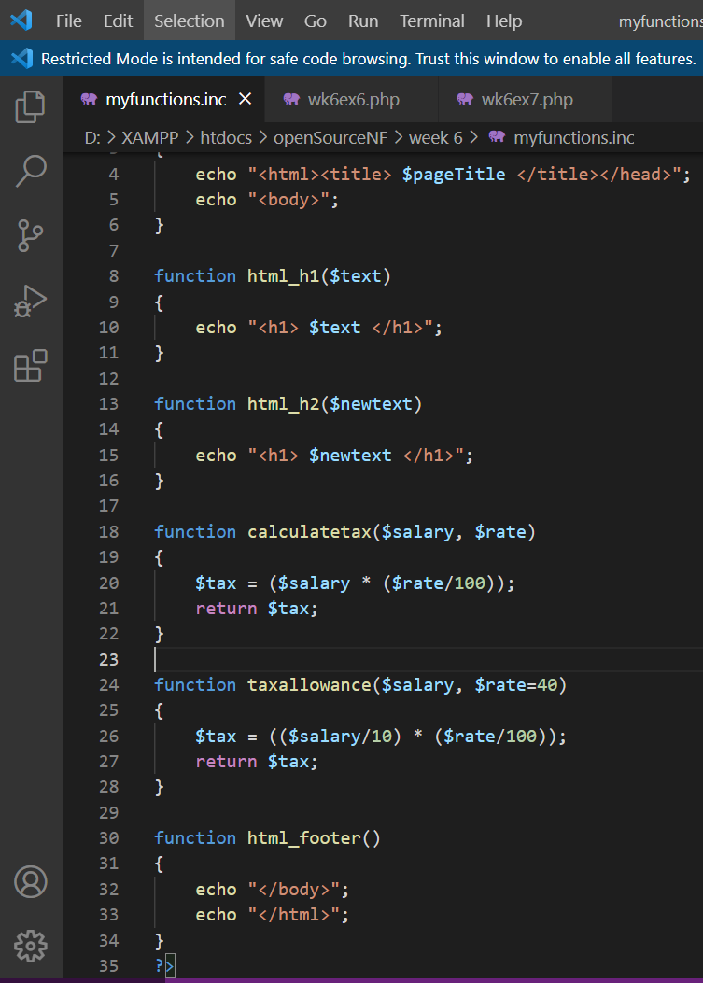

Remember to pass the tax allowance within the function call within wk6ex6.php.

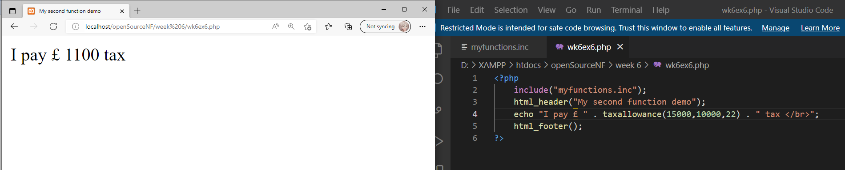
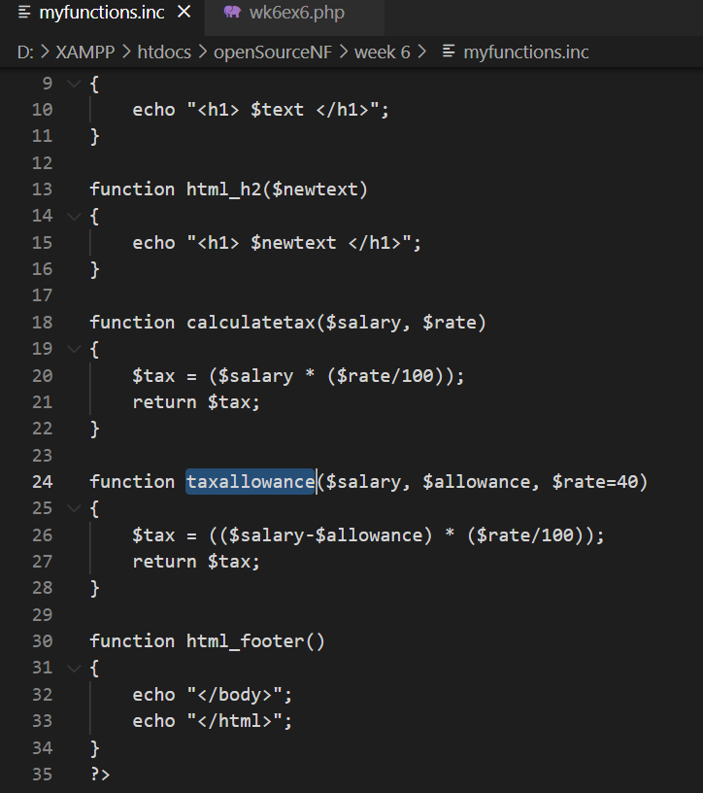

Composer and Phinx PHP Database Migrations

Exercise 9

Install composer on your intweb environment via the command line and demonstrate it has been successfully installed.

The command to run is as follows:

curl -s https://getcomposer.org/installer | php

(You can either connect directly from the command line using SSH or you can use PuTTY on the university machines)

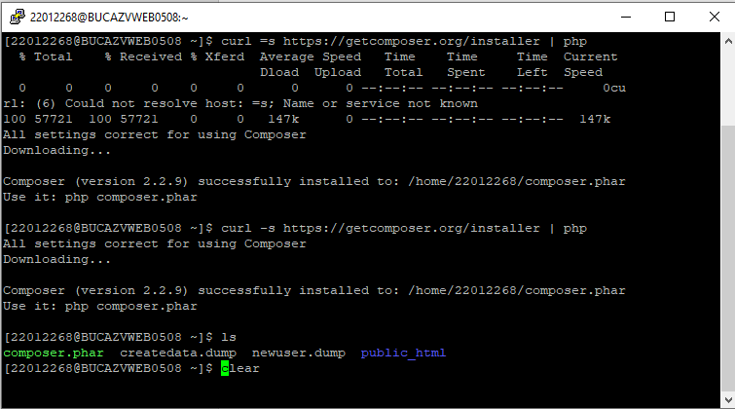

Exercise 10

Install Phinx on your intweb environment into a new project folder within “public_html” via the command line by using composer.

(Refer to the screencast demonstration / lecture recording for more details.)

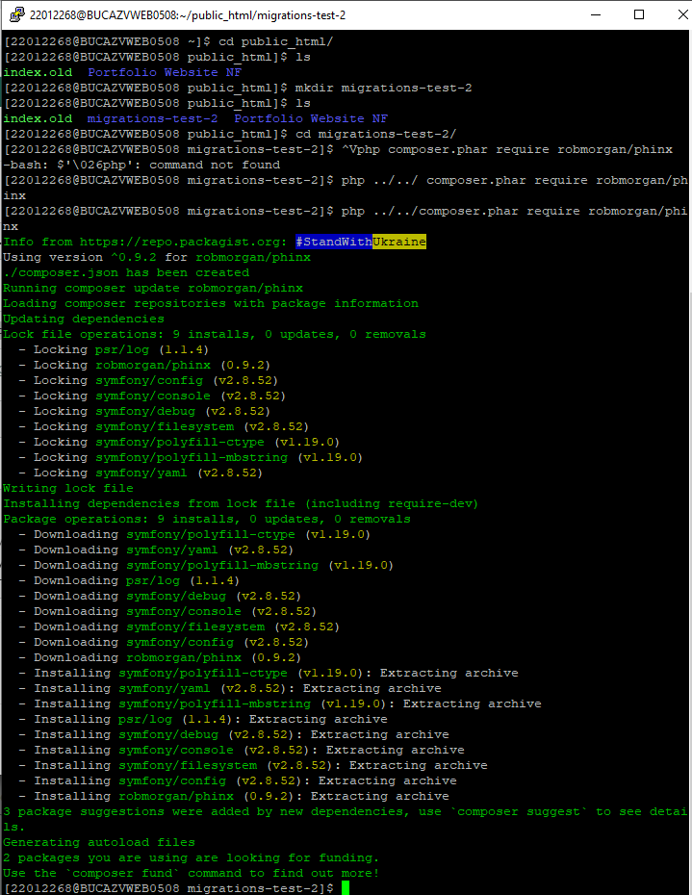

Exercise 11

Create a new database migration that makes some change to your database using the change() method. Screenshot your code and evidence of the migration having been run.

Hint: once you have coded your migration, the CLI command you can use is (assuming you are using the “production” environment):

phinx migrate -e production

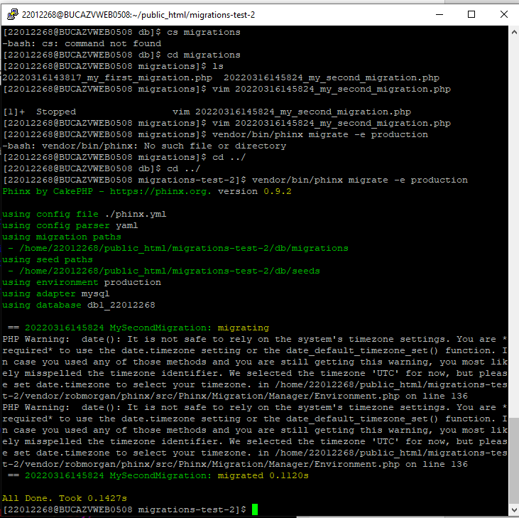

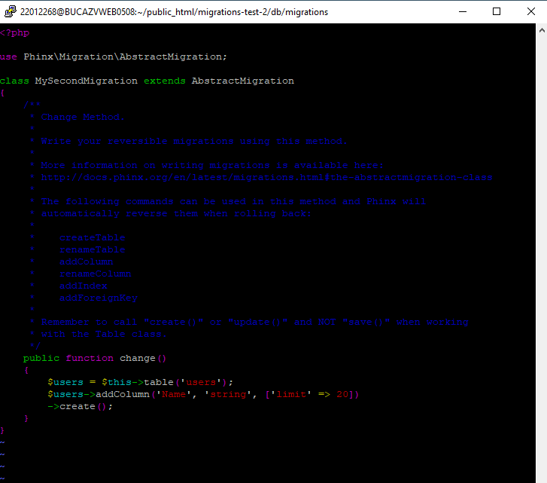

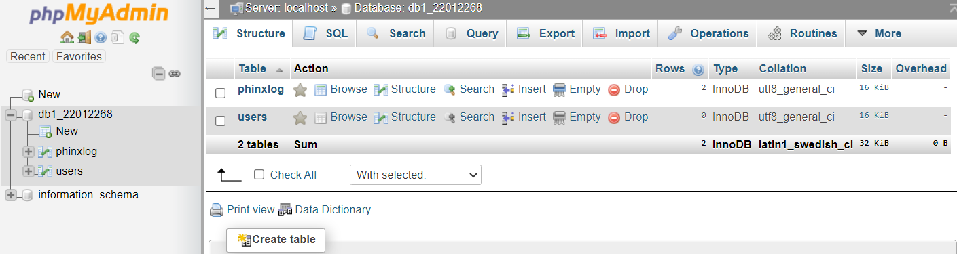

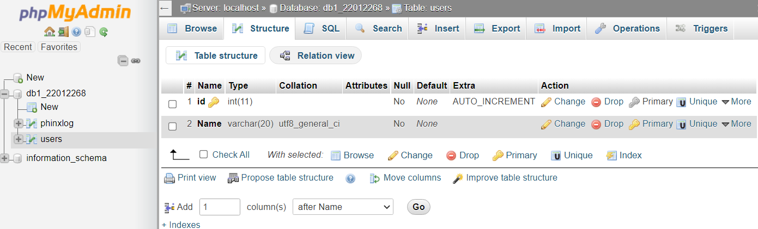

Exercise 12

Create a new database migration that makes some change to your database using the up() method. You will need to create a down() method also. Screenshot your code and evidence of the migration having been run.

Hint: once you have coded your migration, the CLI command you can use is (assuming you are using the “production” environment):

phinx migrate -e production

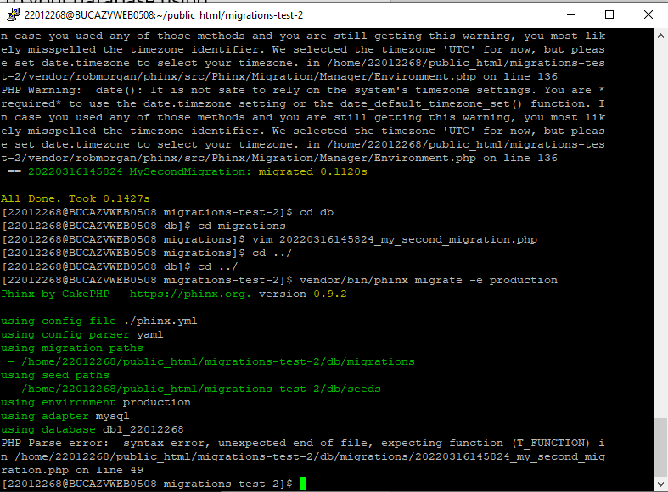

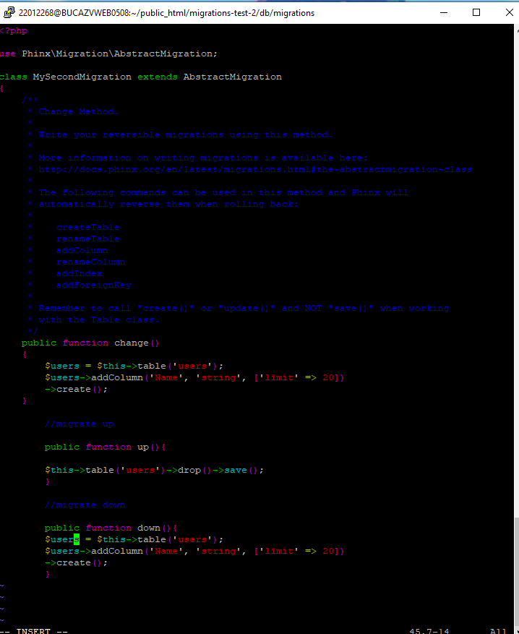
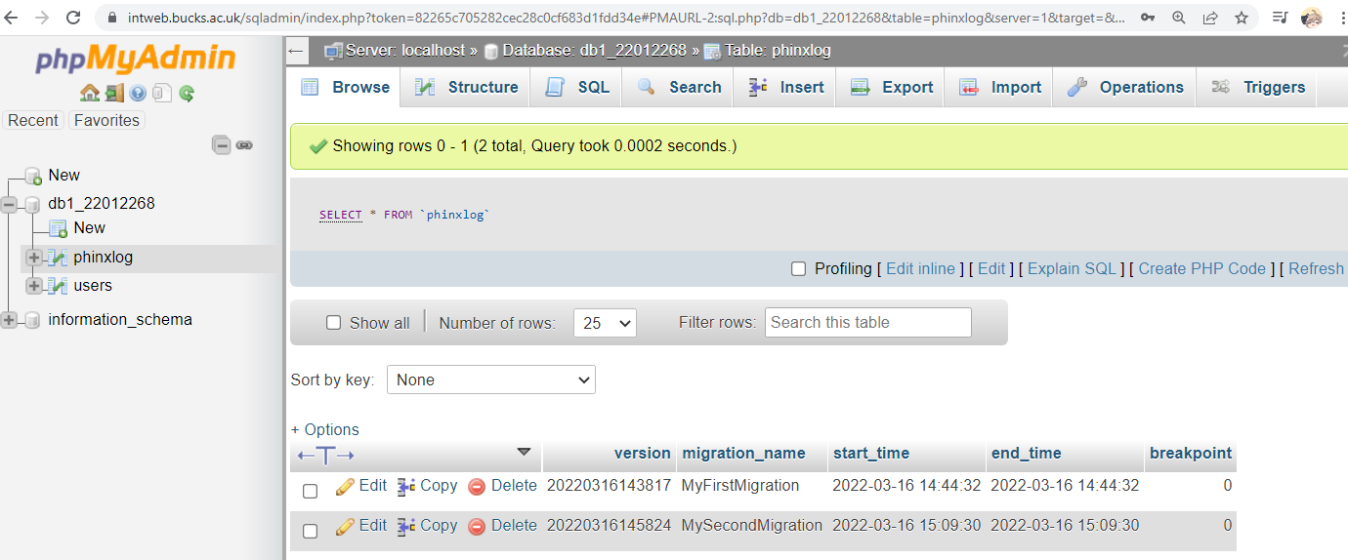

Exercise 13

Rollback your migrations to check that they revert successfully and bring your database back into its original state (e.g. if you started with an empty database before running the migrations, after you’ve reverted you migrations you should end up with an empty database again).

Hint: try this command to rollback all migrations (assuming you are using the “production” environment):

phinx rollback -e production -t 0

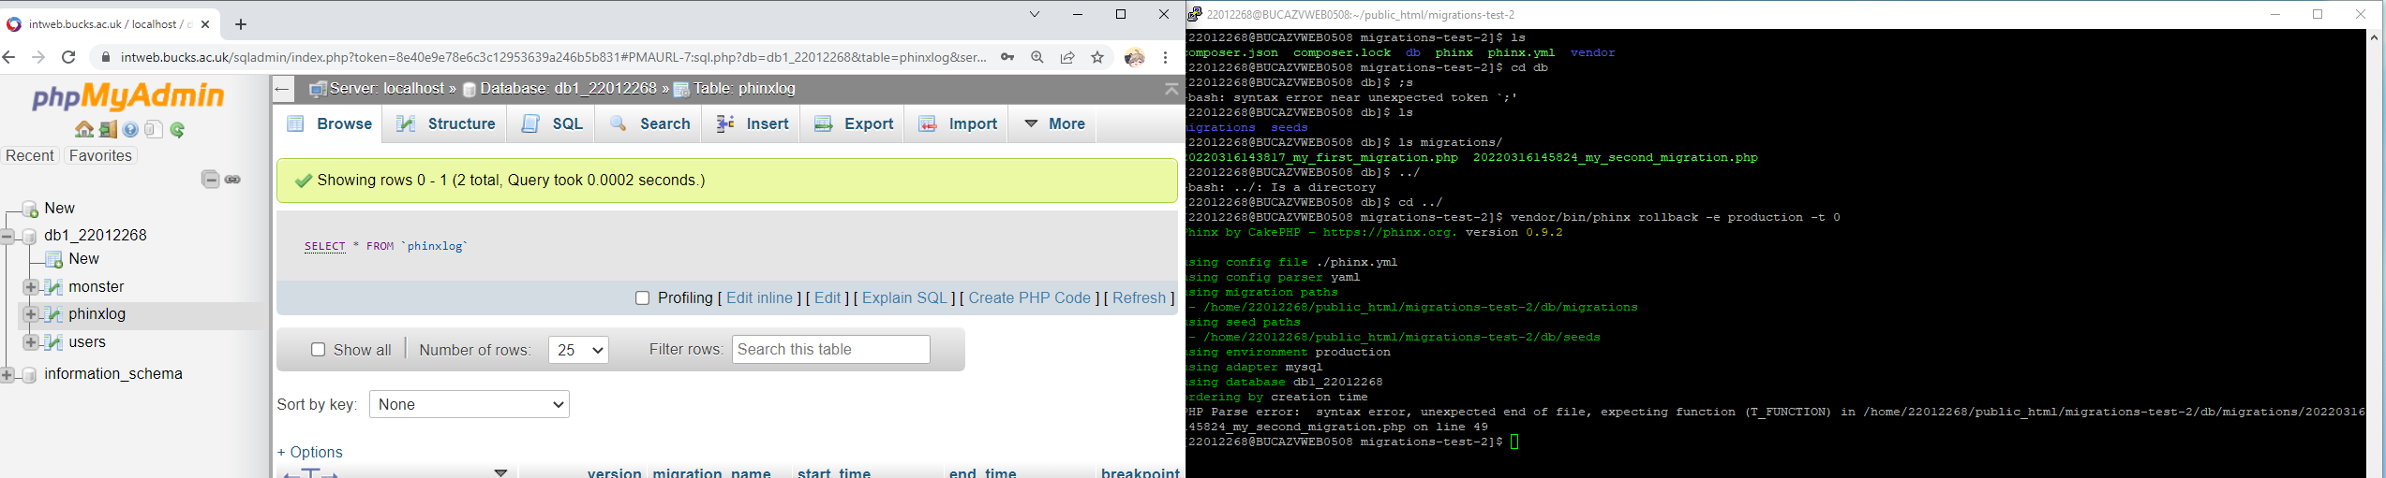

Reminder:

Continue with the SoloLearn PHP course either via the web or via the mobile: https://www.sololearn.com/Play/PHP

In your final logbook/handout, you will be asked to provide evidence that you completed the whole course in the form of a screenshot of your progress or a screenshot of the certificate of completion.

